# SCREENSHOTS OF THE GOOGLE FORMS EMAIL AND REFLECTIONS ON THE COURSE:

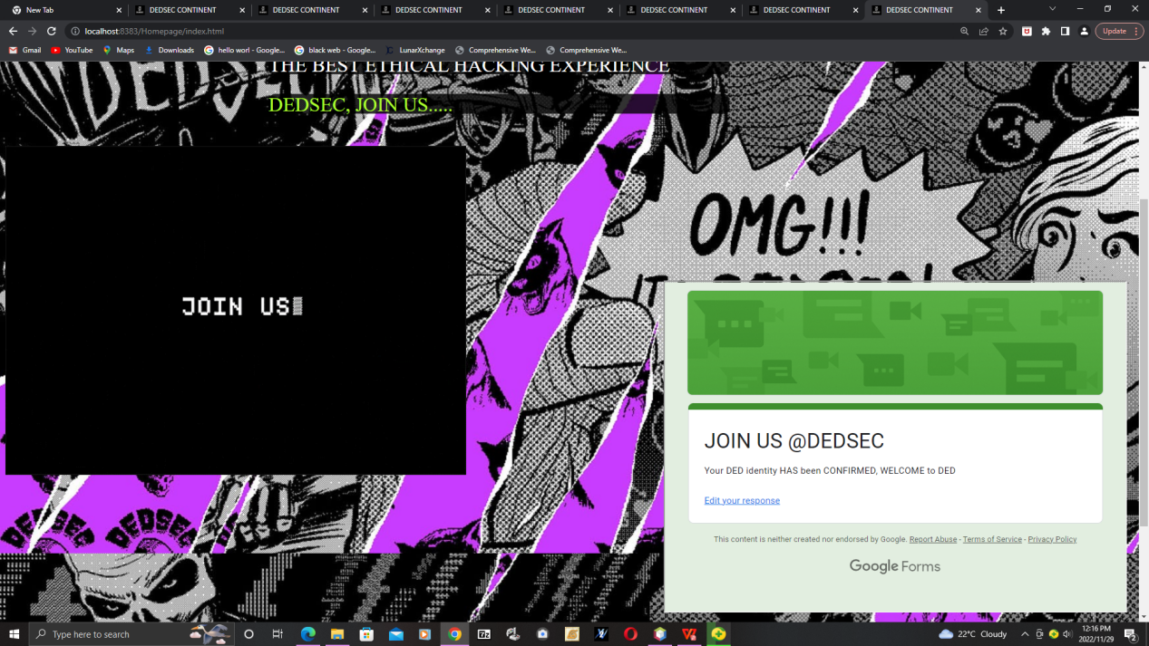

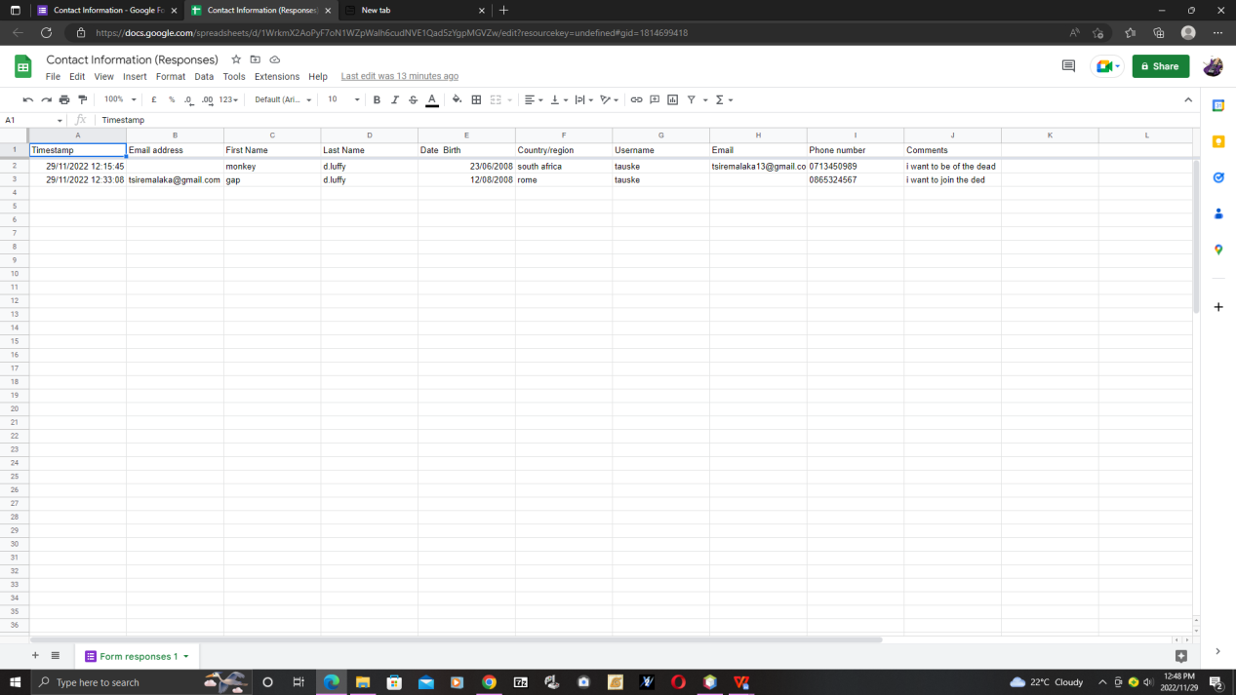

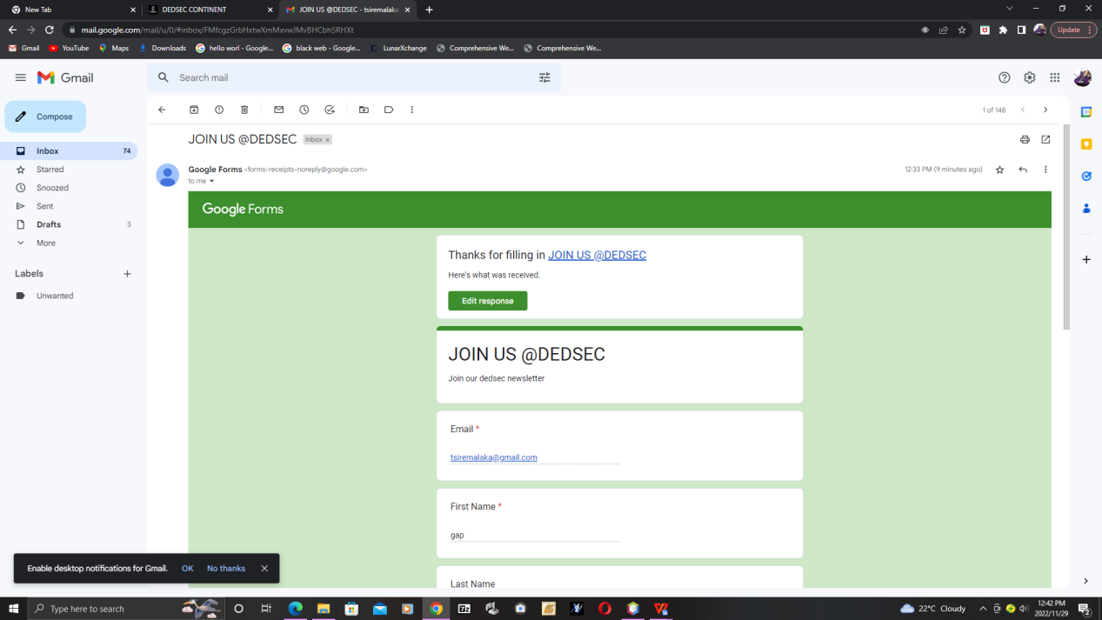

# REFLECTION:

**Beneficial aspect of the course :**

The course has supplied me with sufficient skills to implement a variety of techniques to web building and web designing which has helped me understand how websites and web pages are made and processed

**Least beneficial aspects:**

The course has really displayed a lengthy amount of study and knowledge of each aspect of HTML and CSS that are required to properly make and design a beautiful working web page or website other than that it has also provided on sight proof that web design requires you to have a good grasp of creativity and a vivid mind

**Learning units :**

The learning units in this course have helped me master different aspects of css and html in their own respective ways it has helped me understand how the computer communicates with the web browser to present a wonderful display of complex creativity and flamboyancy

**Knowledge helping :**

The knowledge I gained from this learning unit has assisted me in properly adjusting and being able to resize and shift not only that but also overlapping and

Creative design

**Will I use the skills :**

Yes in my future career I will utilize this skills to build a platoon of websites for powerful companies and ultimately end up becoming a full stack developer that will most likely design pages for google or apple

**If I were to rewind:**

If I were to go back and restart this course id most likely practice how to properly design and build creative interactive pages that have beautiful and lush designs but also are filled with responsive design and ideas

Though if I were to do something again it would be to thoroughly take my time to enjoy how fun and varied the skills ive learned so far are